# Assignment 1

Your answers must be in a word format.

Instructions:

Marks will be deducted for late assignments.

* Change the font of terminal to 14 and have green/black pallet.
* Copy- paste screenshot of your terminal for each question below.
* Use Control + Printscreen or equivalent option to save screenshot not clipping tool.
* Ensure prompt shows as your fulllname@fedora or fullname@localhost
* Only provide answer to what question asks – clear the screen is recommended.
* Submit the word file to blackboard.

Write the linux commands to accomplish the following tasks as per the instructions from your Instructor/Professor

1. Make a directory under your home directory called documents. Next, make a directory

under the documents directory called spreadsheets. What is the absolute path

for the spreadsheets directory?

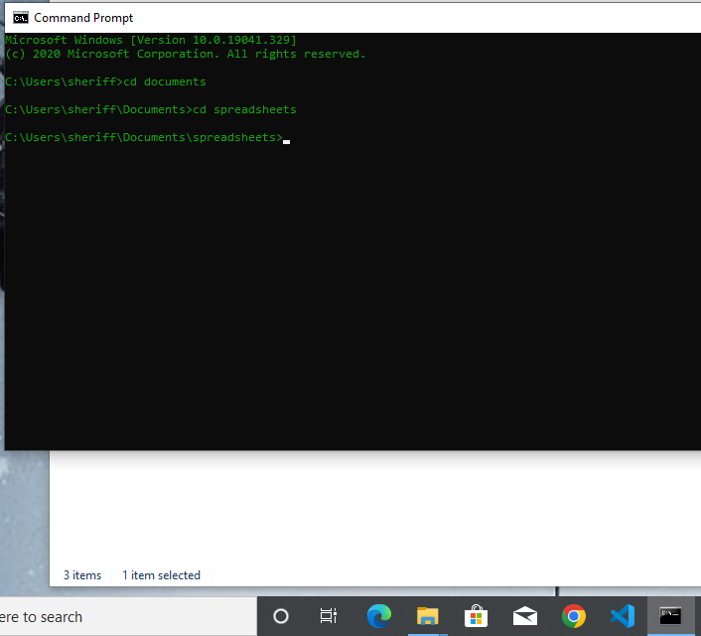

2. Use the cat/vi command to create a two-line file in your home directory called datainfo.

On the first line, enter 144, and on the second line, enter 288. After the file is created,

copy it from your home directory to the spreadsheets directory you created.

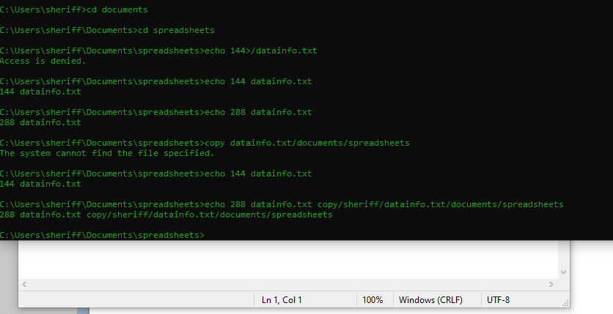

3. Set the permissions on the datainfo file so that the owner, group, and others can read and execute the file. (Otherwise, leave the default settings as is.)

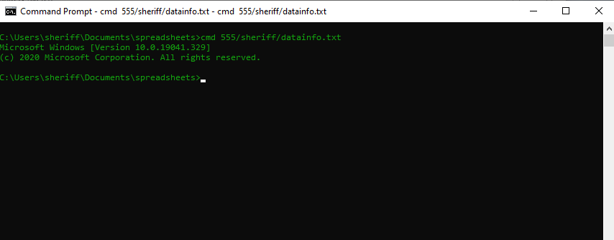

4. Append the current month’s calendar to the datainfo file that is in your home

directory. Next, copy your changed datainfo file over the older datainfo file in the

spreadsheets directory, but use the copy option that prompts you before you overwrite

the file in the spreadsheets directory. Check the contents of the datainfo file in

the spreadsheets directory to make certain your copy was successful.

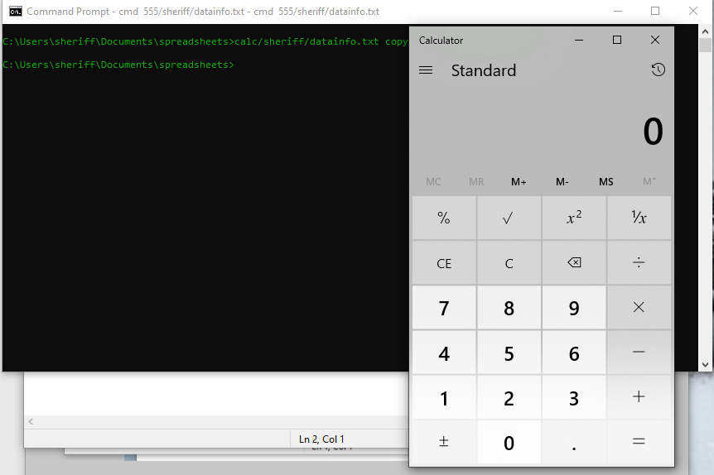

5. Make the spreadsheets directory your working directory. Make copies of the datainfo

file in the spreadsheets directory, so that one copy is named myinfo and one is

named datadata. Next, use  a wildcard character combination to list all files that have “ata” as the second, third, and fourth characters.

6. Make certain you are in your home directory. Change your command prompt so

that it shows your current working directory with an exclamation point, such as

Mydirectory!  --To be discussed in class on due date..

7. Change to your home directory. Use the rmdir command to delete the spreadsheets

directory. What happens?

8. Delete the datainfo files in both your home directory and in the spreadsheets

directory. Also, delete the myinfo and datadata files in the spreadsheets directory.

9. Change to your home directory. Delete the spreadsheets directory and then delete

the documents directory.

10. Create a directory called secure under your home directory. Next, using the octal

permission format, set security on the secure directory so that you have all permissions

and no one else has any permissions.